MAHARASHTRA STATE BOARD OF TECHNICAL
EDUCATION
(ISO -9001-2008) (ISO/IEC 27001 – 2013)


JSPM’S Bhivarabai college of polytechnic
2025-26
PROJECT REPORT FOR INDUSTRIAL TRAINNING (2025-26)

TechgeekConnect Technologies IT Training and Software Solution ,Wagholi Pune :-
Submitted By :-

Name Of Student | Enrollment No
Piyush Pravin Potghan | 23211820412





MAHARASHTR BOARD OF TECHNICAL EDUCATION
(ISO -9001-2008) (ISO/IEC 27001 – 2013)

CERTIFICATE OF COMPLETION
This is to certify that the following student of semester 5th of Diploma in Computer Engineering of Institute jspm bhivarabai college of polytechnic have successfully Completed training as a “ Web & Operations Intern ” in the course of “ Internship (315004) ” for the academic year 2025-26.

Name Of Student | Enrollment No
Piyush Pravin Potghan | 23211820412

Place : wagholi Date : 12/9/2025
Guided By :

(Mrs. Pooja Gavandkar)
Guide Internship Mentor External Examiner

HOD sign

ABSTRACT

This report details the industrial training undertaken at TechGeekConnect Technologies, focusing on web development. It presents the development of a web-based project titled “Doctor Appointment System”, designed to streamline the process of scheduling and managing medical appointments between patients and healthcare providers.
The primary objective of this project was to create a digital healthcare appointment platform that simplifies and automates the appointment booking process, ensuring efficient communication between patients, doctors, and administrators. The web application was developed using the MongoDB, Express.js, React.js, and Node.js (MERN) stack, ensuring usability, scalability, and real-time data synchronization.
The system includes features such as appointment booking, doctor management, patient registration, application approval by the admin, and downloadable appointment confirmations. It also provides role-based access for patients, doctors, and administrators, ensuring smooth workflow and transparency. The report highlights the system architecture, database design, and implementation methodology.
The Doctor Appointment System not only provided hands-on experience in full-stack web development but also improves the efficiency of healthcare services by reducing paperwork, minimizing manual errors, and enhancing communication. This project bridges the gap between patients, doctors, and administrators, creating a smarter and more connected healthcare environment.

ACKNOWLEDGEMENT

We have great pleasure in submitting this project report on TechGeekConnect Technologies. We would like to take this opportunity to express our great gratitude for the encouragement, guidance, and insight provided during the project work.
We also appreciate the professional, timely, and valuable advice, as well as the continuous schedule follow-up, constructive criticism, supervision, and valuable comments during our project work. We also thank Mrs. Pooja Gavandakar (Director) for her co-operation and suggestions in making this project.
We especially thank Mrs. Sonali Patil, HOD of Computer Department, JSPM Bhivarabai Sawant College of Polytechnic, for her kind co-operation and support.

Submitted by

Mrs. Piyush Pravin Potghan (23211820412)

INDEX

Sr. No | Chapter Name | Page No.
1 | Organization Structure of Industry and General Layout | 7
2 | Introduction to Industry / Organization | 9
3 | Types of Major Equipment’s and Software Used | 11
4 | Processes/Manufacturing Techniques and Methodologies | 13
5 | Testing of Software | 15
6 | Safety Procedures Followed in Industry | 17
7 | Particulars of Practical Experiences in Industry | 19
8 | Detailed Report of the Tasks Undertaken | 21
9 | Special/Challenging Experiences Encountered | 28
10 | Conclusion | 30
11 | References / Sources of Information | 31

CHAPTER 1:

Organization Structure of Industry and General Layout Company Overview:
TechGeekConnect Technology is an IT training and software solutions company established in December 2022. It is located on the 3rd Floor, Blue Sky Icon, Baif Road, opposite Parvatibai Genba Moze Engineering College, Wagholi, Pune. The company provides IT training, software development, and digital solutions. It operates in the Information Technology and Education industry and has received a rating of 4.7 out of 5 based on reviews. The company also maintains an online presence through its website techgeekconnect.com.

Organizational Structure:
The company follows a standard IT training organizational structure. At the top, the Founder/CEO manages the overall operations and strategic direction of the company. Training coordinators are responsible for managing course schedules, student enrollments, and coordinating with faculty members. Faculty members deliver training across various domains such as programming, web development, cybersecurity, and data analytics. Support staff handle administrative work, student queries, and the maintenance of company facilities. This hierarchical structure ensures smooth functioning and effective management of both training and operational activities.

Infrastructure and Facilities:
TechGeekConnect Technology provides a modern and well-equipped environment for learning. The classrooms are spacious and well-lit to support interactive learning. Computer labs are equipped with the latest software, allowing students to gain practical experience. There are dedicated project rooms for group work and collaborative projects. Additionally, the company offers online learning platforms so students can access digital resources and attend virtual classes when needed.

Training Programs:
The company offers a wide variety of training programs tailored to industry needs. Students can learn programming languages such as C, C++, Java, Python, and ReactJS. Web development courses cover both frontend and backend development. Cybersecurity courses include ethical hacking and network security. Data analytics training is provided to help students learn tools and techniques for analyzing data effectively. Additionally, the company focuses on soft skills development, including communication, leadership, and interview preparation.

Vision and Mission:
TechGeekConnect Technology aims to bridge the skill gap in the IT industry by providing high-quality training. Its mission is to empower students and professionals with practical knowledge and hands-on experience, enabling them to excel in the rapidly evolving technology landscape.

Visual Insights:
For a visual understanding of the company, training sessions, and infrastructure, images are available on Justdial.

Introduction:

CHAPTER 2 :
Introduction to Industry / Organization

TechGeekConnect Technology is a prominent IT training and software development company based in Wagholi, Pune. Established in December 2022, the company focuses on providing practical and industry- oriented IT education. It aims to bridge the gap between academic knowledge and industry requirements by offering training in the latest technologies and software tools. The organization caters to students, professionals, and companies looking to upskill their workforce in IT-related domains.

Industry Overview:
The company operates in the Information Technology (IT) and Education industry, which is one of the fastest-growing sectors globally. This industry involves software development, IT services, IT-enabled services, and training programs. The IT training sector is particularly significant as it equips individuals with skills required for programming, web development, cybersecurity, and data analytics. With the continuous advancement of technology, the demand for skilled IT professionals is increasing, making companies like TechGeekConnect Technology essential for skill development.

Objective of the Organization:
The primary objective of Our Technology is to provide quality education and training in IT fields to students and professionals. The organization aims to:
- Impart practical knowledge and hands-on experience in various IT domains.
- Prepare students for industry requirements and enhance their employability.
- Offer customized training programs for corporate clients and working professionals.
- Promote digital literacy and technological advancement among learners. Services and Activities:
TechGeekConnect Technology provides a variety of services, including:
- IT training programs for programming languages like C, C++, Java, Python, and ReactJS.
- Web development courses covering frontend and backend development.
- Cybersecurity training including ethical hacking and network security.
- Data analytics and software tools training.
- Soft skills development such as communication, leadership, and interview preparation.

Importance of the Organization:
The organization plays a key role in enhancing the skills of aspiring IT professionals. By offering practical training and up-to-date knowledge, it helps students and professionals stay competitive in the fast-evolving IT industry. Additionally, it contributes to the overall growth of the technology sector by producing skilled and employable individuals.

CHAPTER 3:
Types of Major Equipment’s and Software Used

Introduction

In the web development industry, the "equipment" and "raw materials" are the digital tools, hardware, and assets required to build and deploy a website or web application. This chapter details the specific hardware, software, programming languages, and digital assets that were used in the development of the “CampusConnect” Web Application at TechGeekConnect Technologies.

Hardware Used

The following hardware was essential for the project:

    - Developer Workstation: A Dell Inspiron Laptop equipped with Intel i5 Processor, 16GB of RAM, and a 512GB SSD, running the Windows 11 operating system.
    - Testing Devices: Multiple devices such as desktop PCs, laptops, and smartphones (Android and iOS) were used to test website responsiveness, performance, and compatibility.

Software and Development Tools Used

    - Integrated Development Environment (IDE):
      - Name: Visual Studio Code
      - Use: This was the main editor used for writing, debugging, and building the web application.
      - Approximate Cost: Free.
    - Programming Languages:
      - HTML5: Used for website structure.
      - CSS3: Used for design, layout, and responsiveness.
      - JavaScript (ES6+): Used for interactivity and client-side logic.
      - Node.js & Express.js: Used for back-end development.
      - MongoDB: Used for database management.
    - Key Libraries and Frameworks:
      - React.js: For building a dynamic and responsive front-end.
      - Tailwind CSS: For modern styling and faster UI development.
    - Version Control System:
      - Git & GitHub: Used for source code management, collaboration, and version tracking.

Digital Raw Materials

The primary inputs for this web project were:

    - Database Collections: Datasets containing product details (organic fruits, vegetables, grains, and user accounts) stored in MongoDB.
    - UI Assets: Digital resources such as icons, fonts, and color schemes that were used to build the visual identity of the Soul Organic application.
    - Sample Product Images: High-quality images of organic products used for display in the application.

CHAPTER 4:

Processes/Manufacturing Techniques and Methodologies

- Introduction

Every project follows certain processes and methodologies to ensure that the system is reliable, efficient, and user-friendly. In the case of TechGeekConnect Technologies – Doctor Appointment System, the objective is to digitalize and streamline the process of booking doctor appointments.
The platform integrates multiple features such as doctor profile management, appointment scheduling, patient registration, admin approval, and maintaining digital medical records. Therefore, a well-defined combination of software development processes and technological methodologies is followed to ensure security, accuracy, and scalability.

2. Processes in Doctor Appointment System
The processes involved in the Doctor Appointment System can be divided into five major stages:

(a) User Onboarding & Registration
- Registration of patients and doctors on the platform.
- Secure authentication and role-based access (Admin, Doctor, Patient).
- Profile creation and verification for doctors.

(b) Data Management & Access Control
- Patient information and appointment details stored in the database.
- Doctor availability schedules maintained and updated in real-time.
- Appointment requests sent to the admin for approval or rejection.
- Approved appointment details accessible to both doctor and patient.

(c) Development & Integration
- Frontend developed using React.js, HTML, CSS, and JavaScript.
- Backend powered by Node.js and Express.js.
- Database designed using MongoDB for scalability and data integrity.
- APIs integrated for communication between different modules.

(d) Testing & Quality Assurance
- Unit testing of individual modules.
- Integration testing for smooth workflow between frontend and backend.
- Security testing for authentication and sensitive patient data.
- Debugging and performance optimization to ensure reliability.

(e) Deployment & Maintenance
- Deployment of the system on a secure cloud platform.
- Continuous monitoring and bug fixing.
- Regular updates based on feedback.
- Database backup and recovery system.

3. Handling / Technological Techniques Used
Since the Doctor Appointment System deals with patient and doctor data, it requires accuracy, security, and efficiency. The techniques include:
- Authentication & Authorization Technique
  - Secure login with encrypted passwords.
  - Role-based access (Admin, Doctor, Patient).
- Database Management Technique
  - Use of MongoDB for flexible and scalable storage.
  - Data indexing and retrieval for faster performance.
- User Interface & Experience Technique
  - Responsive UI using React.js.
  - Intuitive dashboards for different users (doctor, patient, admin).
- Digital Methodology (IT-driven)
  - Online appointment booking and approval system.
  - Real-time doctor availability updates.
  - Digital storage of patient history and appointment records.
- Sustainable Methodology
  - Paperless appointment and record management.
  - Reduced manual errors by automating tasks.
  - Scalability to integrate future healthcare features.

4. Methodologies Followed
The Doctor Appointment System adopts the following methodologies:
- Agile Methodology – Incremental development with continuous feedback.
- Quality Assurance Methodology – Ensuring accuracy of appointments and data security.
- User-Centric Methodology – Focus on ease of use, transparency, and patient–doctor communication.
- Technology-Integrated Methodology – Leveraging modern web technologies for efficiency and reliability.

CHAPTER 5:

Testing of Software

- Introduction

Software testing is an essential part of the Software Development Life Cycle (SDLC). It ensures that the developed software meets all requirements and is free of defects.
In the Doctor Appointment System, testing plays a crucial role in ensuring the platform works smoothly for patients, doctors, and admins. Since the system manages sensitive data like patient records, appointment schedules, prescriptions, and reports, testing ensures reliability, accuracy, security, and user satisfaction.

2. Objectives of Software Testing
- Detect and fix errors or bugs in the system
- Verify that the software meets functional and non-functional requirements
- Ensure secure authentication and role-based access control
- Check the performance and scalability of the system
- Improve user experience through usability testing

3. Types of Testing Used
(a) Functional Testing
- Checks that each feature works as expected
- Examples: Patient registration, booking appointments, doctor approval, prescription upload
(b) Unit Testing
- Tests individual components like login, appointment booking logic, and notification sending
- Conducted by developers during coding
(c) Integration Testing
- Tests how different modules work together
- Example: Linking patient details with booked appointments and doctor availability
(d) System Testing
- Tests the entire system as a whole
- Ensures all modules work together and data flows correctly
(e) User Acceptance Testing (UAT)
- Real users (patients, doctors, admins) test the system
- Confirms it meets their needs before deployment
(f) Performance Testing
- Checks system speed, load handling, and response time
- Example: When many patients book appointments at the same time
(g) Security Testing
- Ensures secure login, encryption, and data protection
- Prevents unauthorized access to patient records
(h) Usability Testing
- Focuses on simple navigation and user-friendly design
- Example: Easy dashboard for patients to view upcoming appointments

4. Testing Methodologies
- Manual Testing – For small modules and UI checks
- Automation Testing – Scripts for repetitive tasks (login, booking, notifications)
- Black Box Testing – Tests functionality without looking into code
- White Box Testing – Developers test internal logic and code structure
- Regression Testing – Ensures new updates don’t break old features

5. Tools Used
- Selenium / Cypress – For automated web module testing
- JMeter – For performance and load testing
- Postman – For API testing
- Manual Checklists – For UAT and usability testing

CHAPTER 6:

Safety Procedures Followed in Industry

Safety procedures are the set of rules, practices, and guidelines followed in industries to ensure protection of workers, equipment, environment, and data. They are necessary to prevent accidents, maintain hygiene, and safeguard digital information. In the context of the Doctor Appointment System, safety is divided into physical safety procedures and digital safety procedures.

2. Importance of Safety Procedures
• Prevents accidents and ensures safety in workplace environments such as clinics, hospitals, and server rooms.
• Maintains reliability and trust among patients, doctors, and administrators.
• Protects the company’s digital assets, patient data, and medical records.
• Ensures compliance with legal, medical, and institutional standards.
• Safeguards against data breaches, cyberattacks, and technical failures.

3. Types of Safety Procedures
(A) Physical Safety Procedures
- Workplace Safety: Proper maintenance of clinic workstations, server rooms, and medical IT equipment.
- Fire and Electrical Safety: Fire extinguishers, alarms, UPS systems, and proper wiring ensure safety.
- Emergency Facilities: First aid kits and emergency exits in workplaces and server areas.
- Hardware Handling: Safe handling of servers, routers, and power supplies to avoid damage or hazards.
- Ergonomic Practices: Comfortable seating and safe workstation setups for staff working long hours.
(B) Digital / Cyber Safety Procedures
- Data Protection: Patient data (appointments, prescriptions, reports) is encrypted and stored securely.
- Secure Authentication: Role-based login, multi-factor authentication, and password encryption.
- System Monitoring: Firewalls, antivirus software, and intrusion detection systems prevent cyber threats.
- Regular Backups: Database backups taken periodically to prevent data loss during failures.
- User Awareness: Training for doctors, staff, and administrators regarding password safety, phishing, and responsible system usage.

4. Emergency Preparedness
The Doctor Appointment System also follows emergency preparedness techniques such as:
• Conducting mock drills for data recovery and system failures.
• Training IT staff for disaster management in case of cyberattacks or server breakdowns.
• Maintaining backup servers and cloud storage for continuous operations.
• Preparing evacuation and recovery plans in case of fire or hardware failure.

CHAPTER 7:

Particulars of Practical Experiences in Industry
Practical experience in industry is considered an essential component of professional education. While theoretical knowledge provides the foundation, practical training gives real exposure to how industries actually function. It allows students and trainees to understand industrial processes, organizational practices, and the importance of teamwork and safety.
1. Introduction
Practical experience in industry is considered an essential component of professional education. While theoretical knowledge provides the foundation, practical training gives real exposure to how industries and digital platforms actually function.
In the context of the Doctor Appointment System, practical exposure allowed us to understand how healthcare institutions manage digital operations like patient appointment booking, prescription handling, medical report uploads, doctor scheduling, and patient record management. This provided a clear idea of both technical and administrative practices followed in real-world healthcare systems.

2. Objectives of Practical Experience
The main objectives of gaining practical exposure through the Doctor Appointment System were:
- To provide awareness of healthcare operations and digital workflows.
- To understand how theoretical MERN stack knowledge is applied in live projects.
- To familiarize with modern tools, frameworks, and deployment methodologies.
- To develop technical, managerial, and collaborative skills.
- To inculcate discipline, responsibility, and time management during project execution.

3. Importance of Practical Experience
• Application of Knowledge: Converted classroom concepts (React, Node.js, MongoDB, Express) into a real-world working system.
• Skill Development: Enhanced both technical (coding, database handling, deployment) and soft skills (communication, coordination).
• Problem Solving: Gave exposure to debugging, error handling, and optimizing system performance.
• Professional Readiness: Prepared us for professional IT careers by simulating industry-level project execution.
• Industry Familiarity: Offered direct observation of how healthcare institutions function digitally and how different stakeholders (patients, doctors, admins) interact on a single platform.
4. Key Areas of Practical Exposure
(A) Development and Operations
• Observed how different healthcare processes (appointments, prescriptions, reports, scheduling) can be digitized.
• Implemented database management for structured patient record-keeping.
• Understood deployment techniques for making the system live and accessible.
(B) Technical Training
• Hands-on practice with MERN stack (MongoDB, Express.js, React.js, Node.js).
• Worked with APIs for data handling and real-time updates.
• Learned troubleshooting methods for server issues, authentication errors, and UI bugs.
(C) Managerial and Administrative Practices
• Understood role-based access (patient, doctor, admin).
• Maintained proper documentation and reports for project progress.
• Observed decision-making in terms of prioritizing features and time management.
(D) Safety and Compliance
• Implemented data encryption and authentication to protect sensitive patient records.
• Understood importance of backups and secure hosting.
• Ensured compliance with data privacy and healthcare guidelines.
(E) User and Stakeholder Interaction
• Analyzed requirements from doctors, patients, and admin perspectives.
• Learned how user feedback improves features and usability.
• Understood the role of proper communication and user interface in system adoption.

5. Benefits of Practical Experience
- Improved adaptability and confidence in handling real-world projects.
- Enhanced problem-solving skills through debugging and live testing.
- Developed teamwork, leadership, and communication abilities.
- Gained professional ethics, discipline, and responsibility during project execution.
- Increased employability by gaining practical skillsets along with theoretical knowledge.

CHAPTER 8:

Detailed Report of the Tasks Undertaken

- Project Title:

Medicare – Doctor Appointment System

2. Project Objective:
The main objective of this project was to design and develop a centralized digital platform for managing healthcare activities such as doctor appointment booking, patient record handling, prescription generation, and admin supervision. The system provides role-based access for patients, doctors, and administrators, ensuring smooth communication and efficient healthcare service management.

3. Key Features and Functionality:
• User Authentication: Secure login and registration with JWT authentication.
• Role-Based Access: Different dashboards and permissions for patients, doctors, and admin.
• Appointment Booking: Patients can book appointments with doctors, view schedules, and receive confirmation.
• Doctor Management: Admin can add or remove doctors and manage their schedules.
• Prescription Handling: Doctors can upload prescriptions after consultations, visible to patients.
• Medical Records: Patients can view their appointment history and prescriptions securely.
• Admin Dashboard: Admin can manage users (patients/doctors), monitor appointments, and view system-wide reports.
• Responsive UI: Mobile-friendly and user-centric design using React and TailwindCSS.

4. My Role and Implementation Details:
As the main developer of the Medicare Project, my responsibilities covered the complete development cycle using the MERN stack.

1. Frontend Development:
• Built the user interface using React.js and TailwindCSS.
• Designed reusable UI components like Navbar, Sidebar, Appointment Cards, Prescription Cards, and Doctor Profiles.
• Implemented routing and navigation using react-router-dom.
• Ensured responsive design for accessibility on mobile and desktop.

2. Backend Development:
• Developed RESTful APIs using Node.js and Express.js.
• Implemented secure authentication and authorization with JWT.
• Created API routes for appointments, prescriptions, doctors, and user management.

3. Database Management:
• Used MongoDB for storing patient, doctor, and admin records.
• Created Mongoose schemas for users, appointments, and prescriptions.
• Implemented data validation and indexing for optimized performance.

4. Integration & Testing:
• Integrated frontend with backend APIs using Axios.
• Performed end-to-end testing for major workflows:
o Patient Login → Book Appointment → View Prescription
o Doctor Login → View Appointments → Upload Prescription
o Admin Login → Add Doctor → View Reports
• Debugged and optimized database queries for better efficiency.

5. Final Outcome:
The outcome of my training and development work was a fully functional Medicare web application. The system provided a digitized solution for managing doctor appointments and patient records, thereby reducing paperwork and increasing efficiency.
The platform allows:
• Patients to book appointments, view prescriptions, and track their medical history.
• Doctors to view patient appointments, consult, and upload prescriptions.
• Admin to manage doctors, patients, and maintain the overall system.
The project successfully demonstrated real-time application of the MERN stack, while contributing towards the modernization of healthcare service management.

Output:

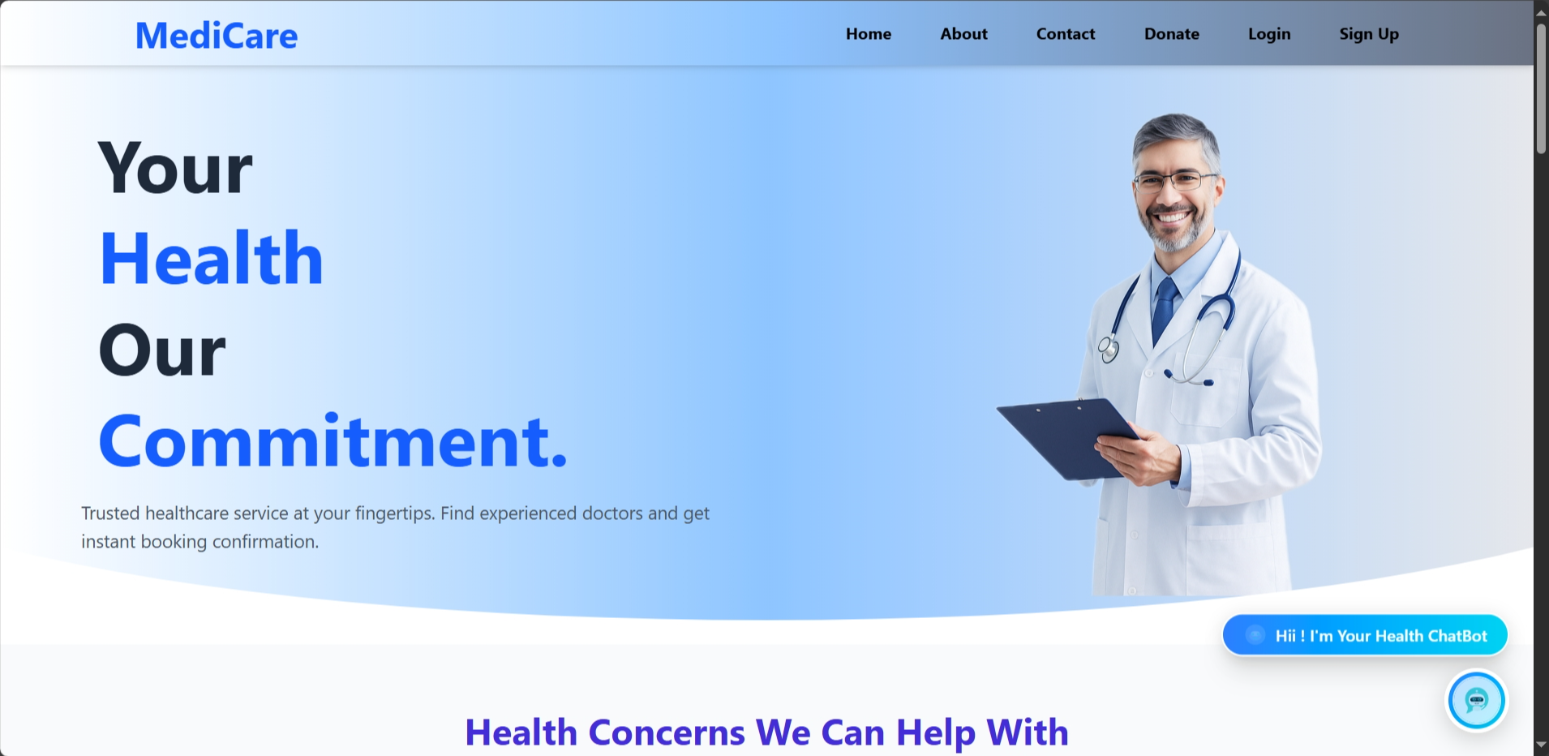

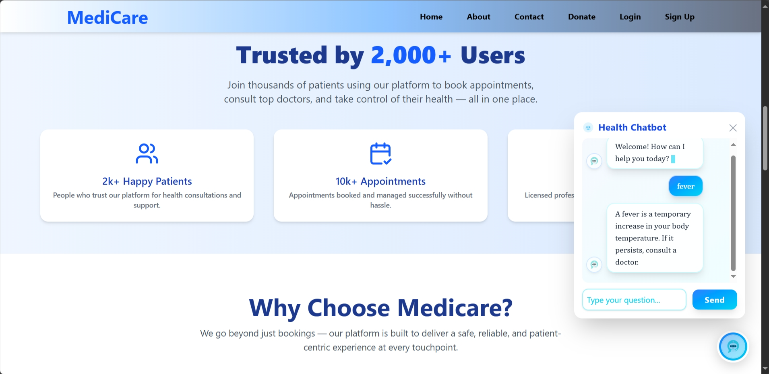

Patient dashboard

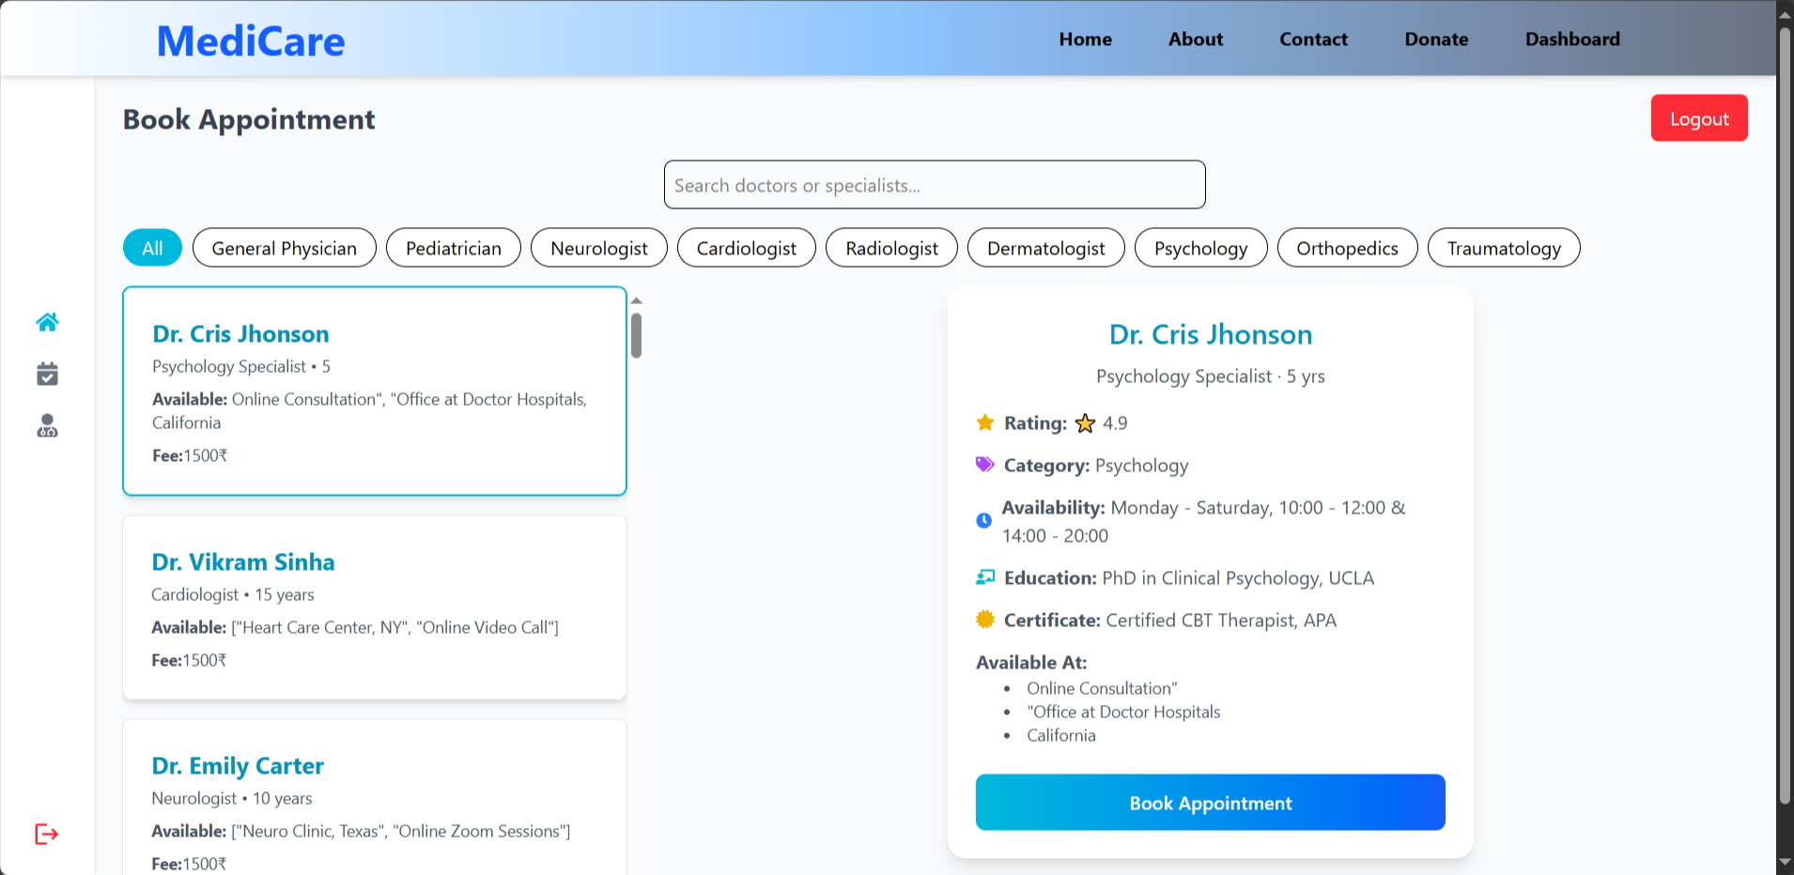

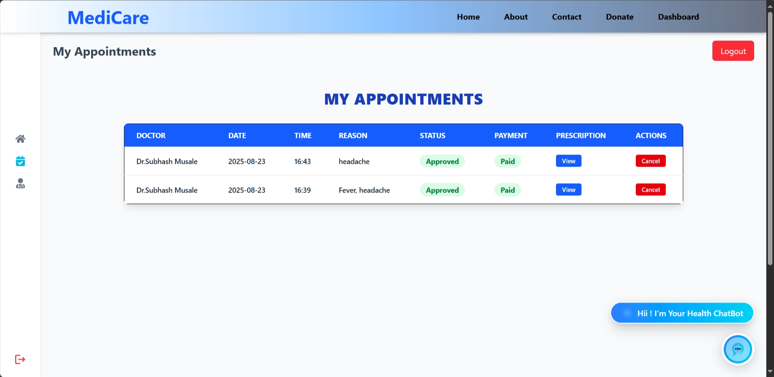

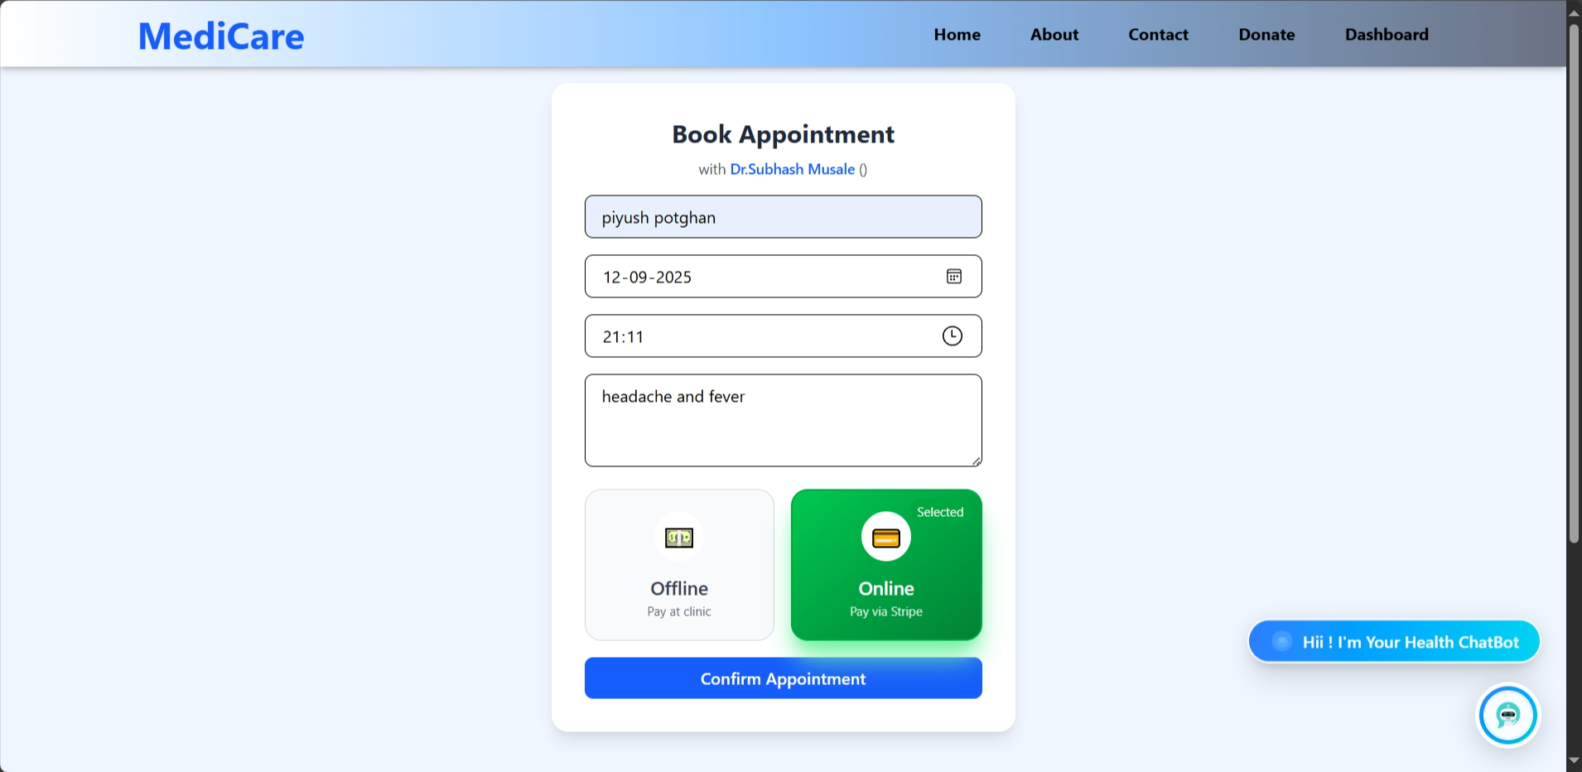

Task Output (admin dashboard) :

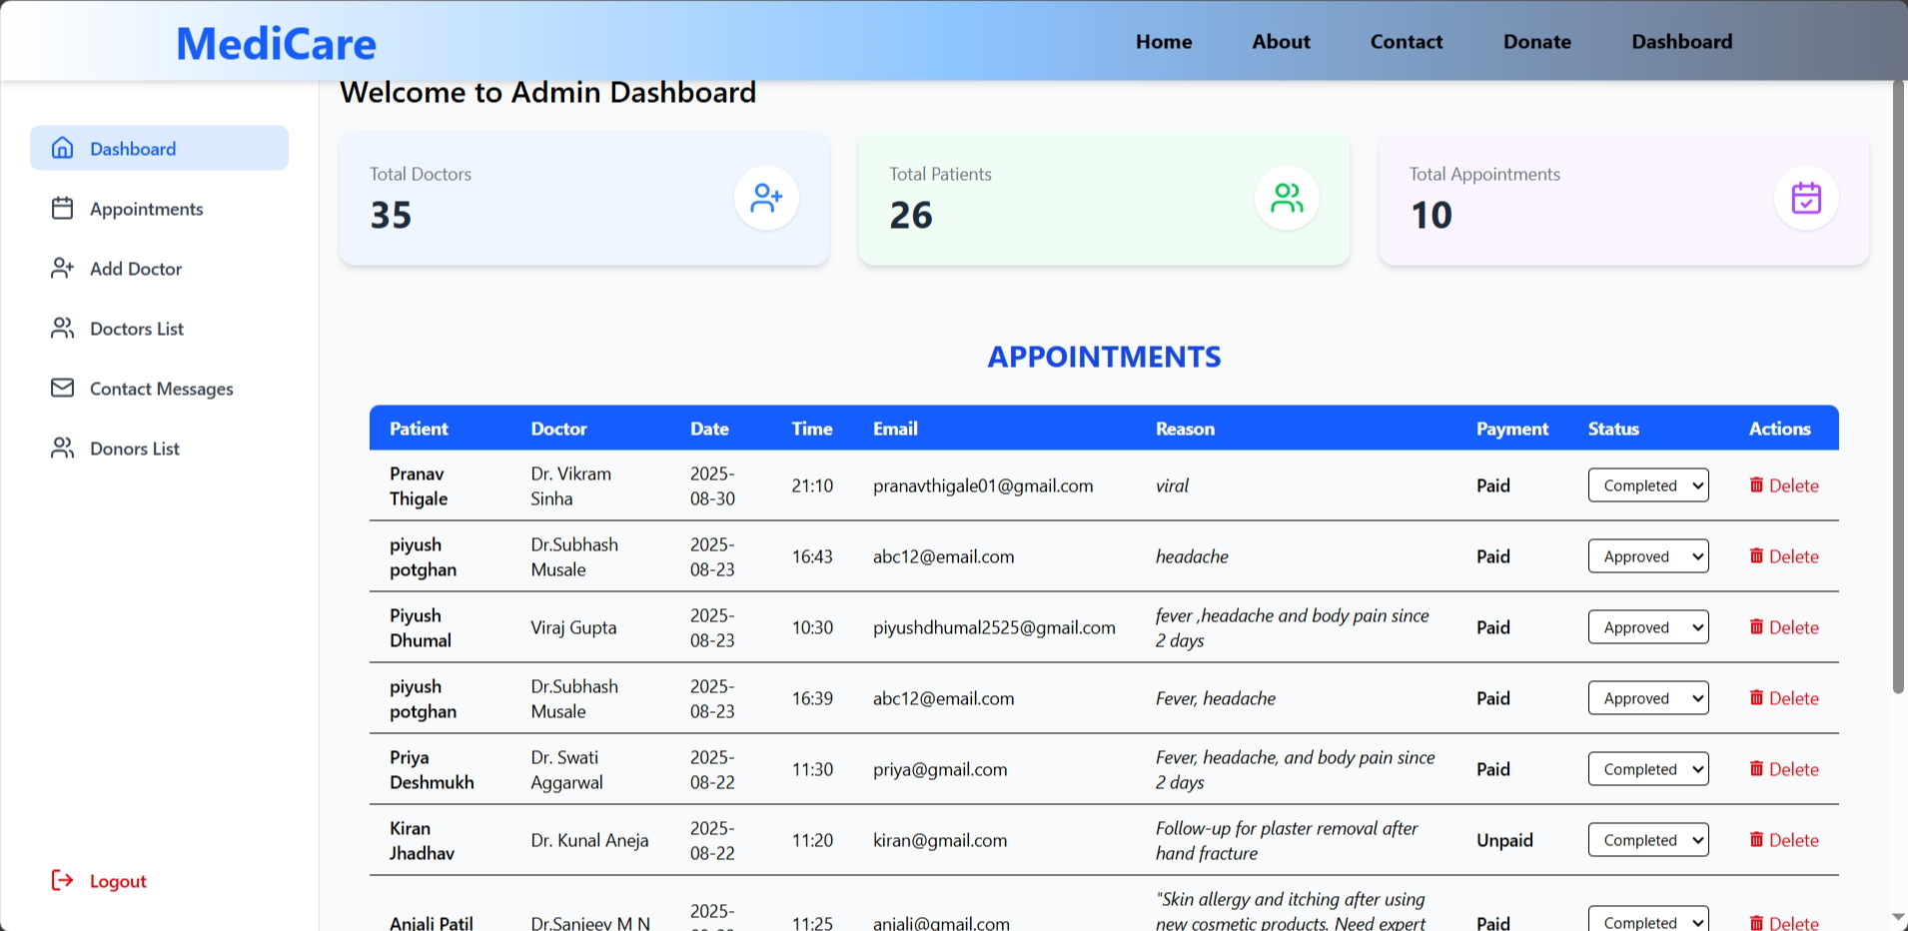

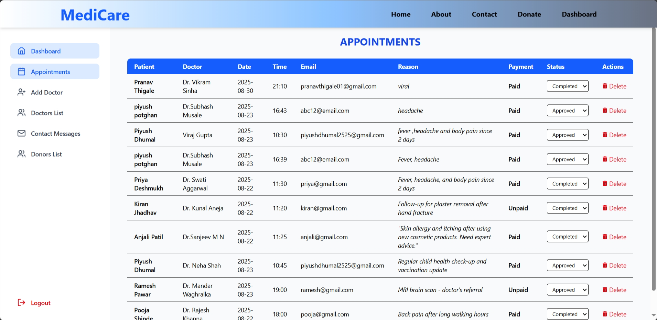

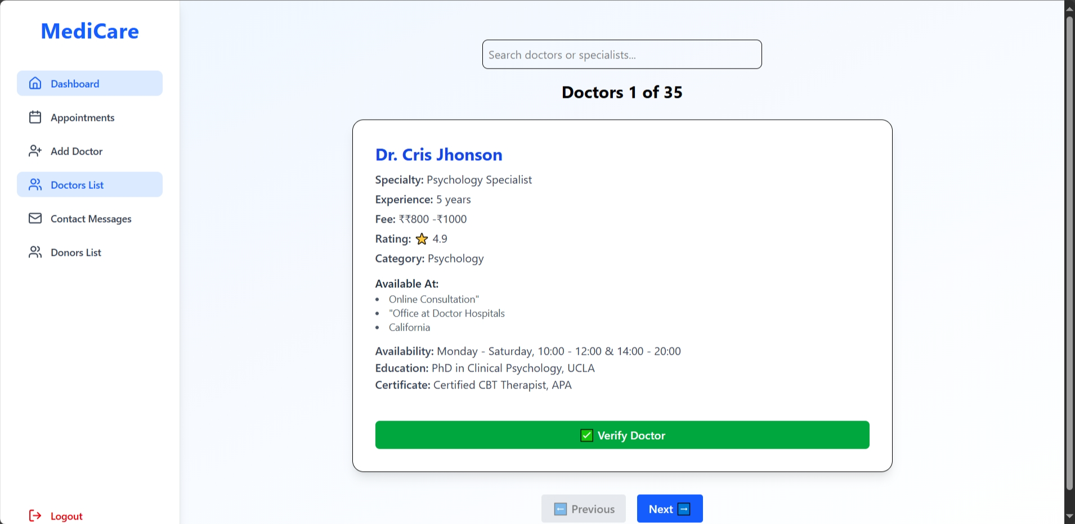

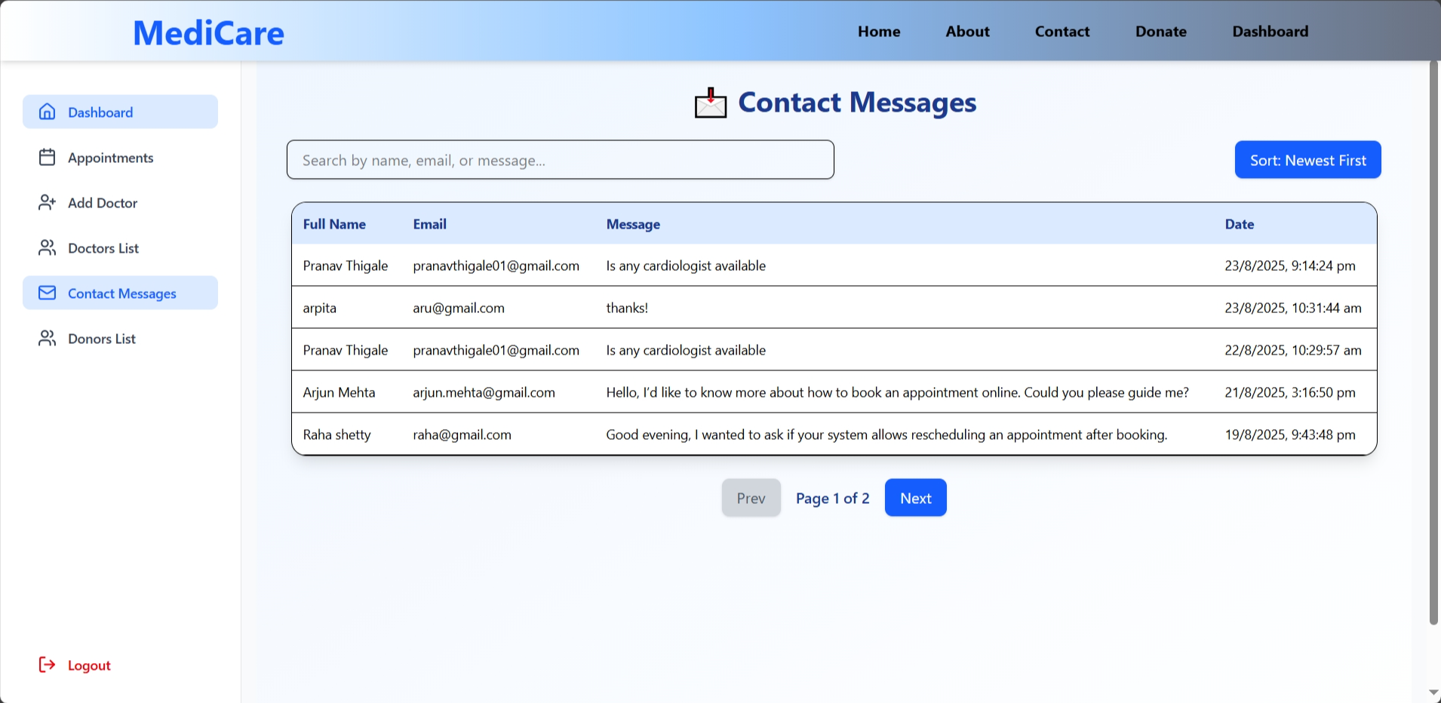

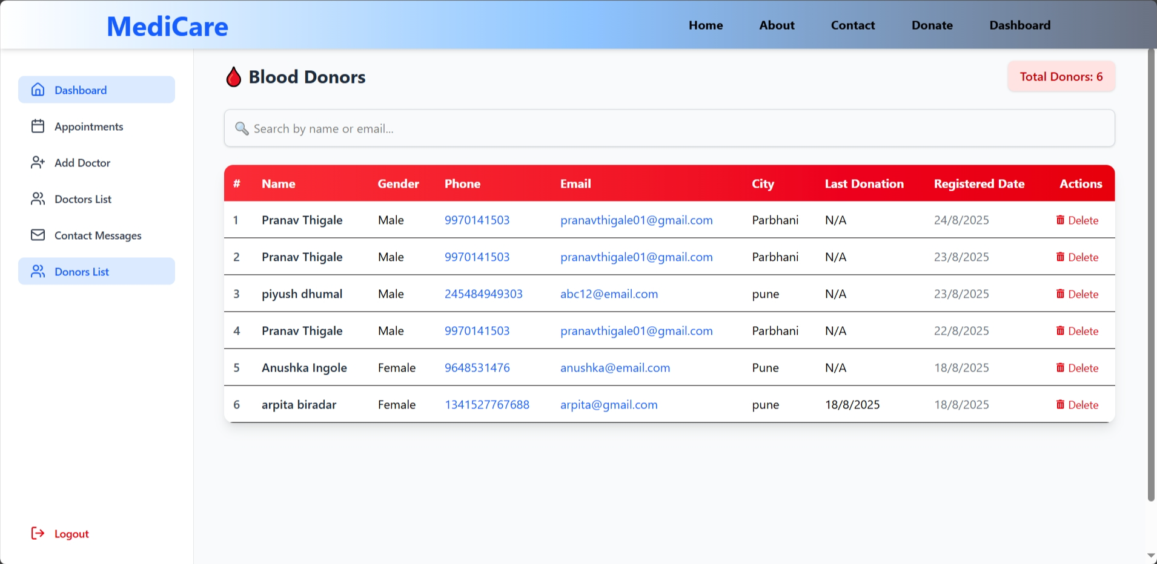

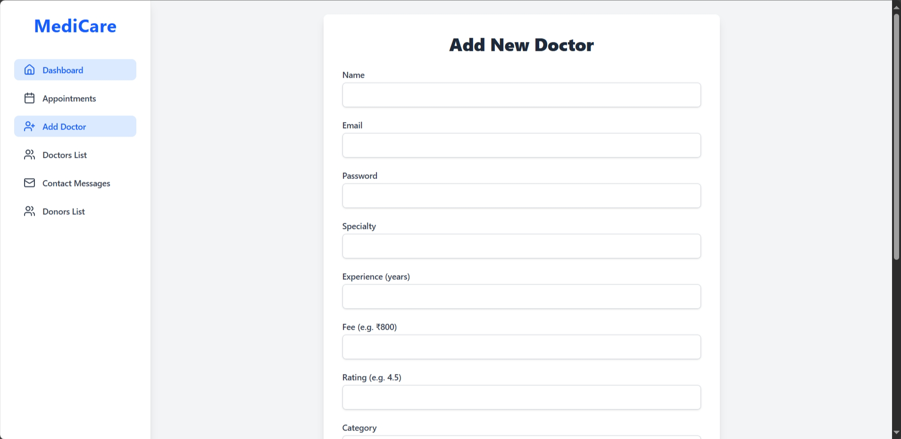

Doctor dashboard

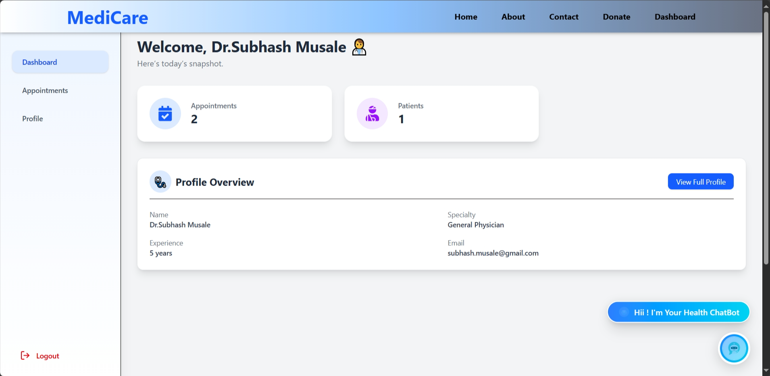

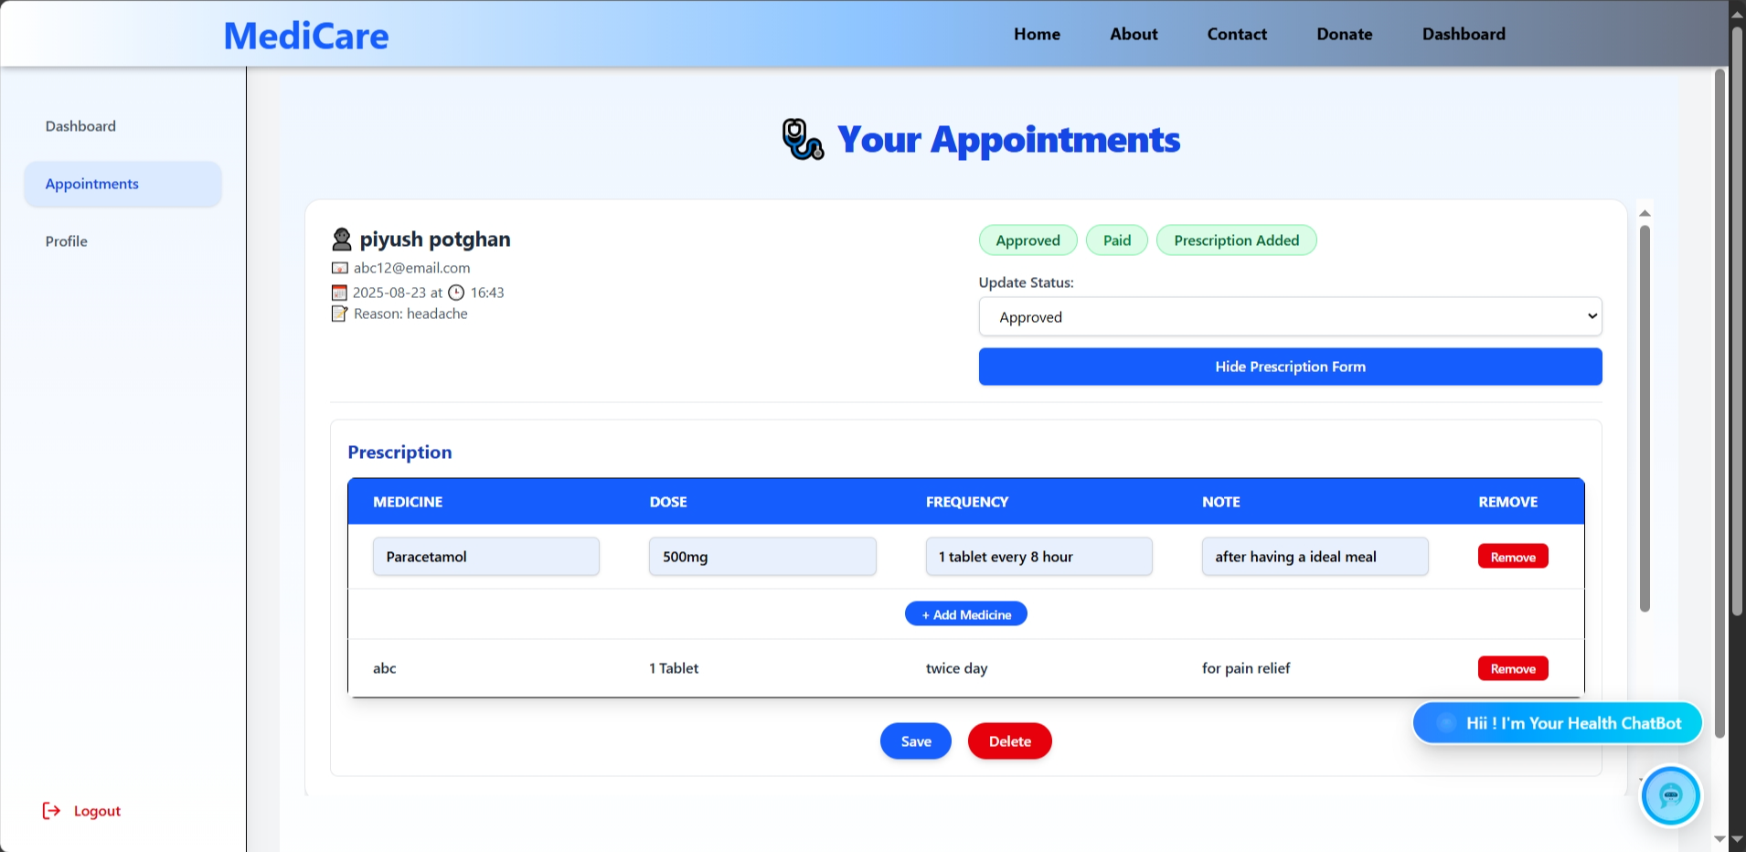

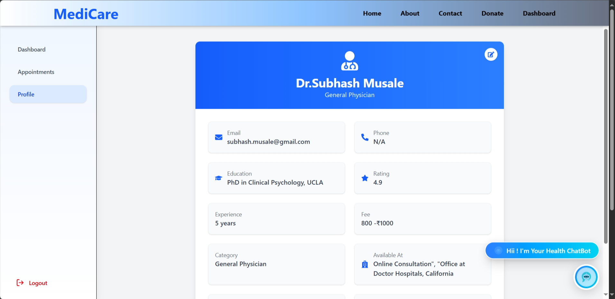

Task Performed in Industry:-

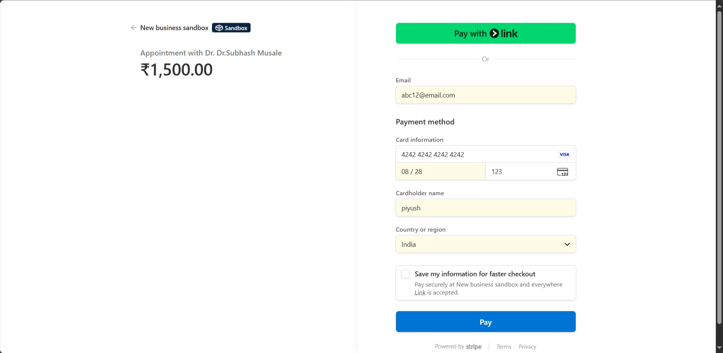

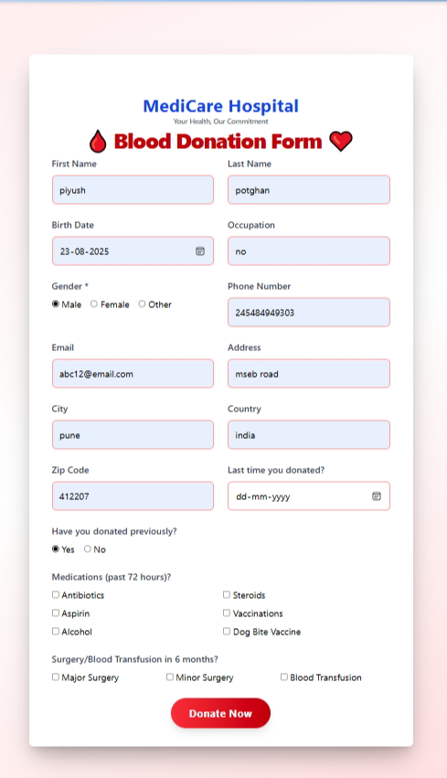

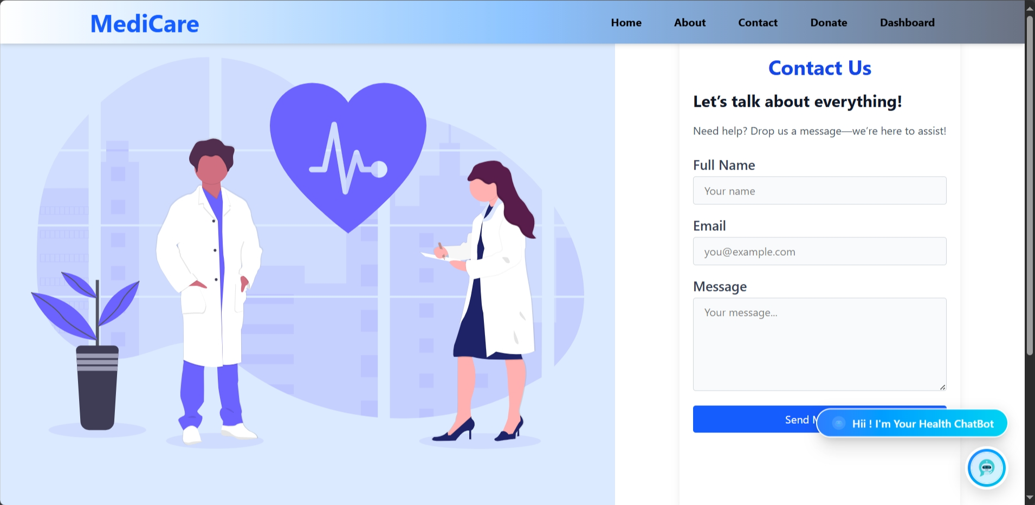

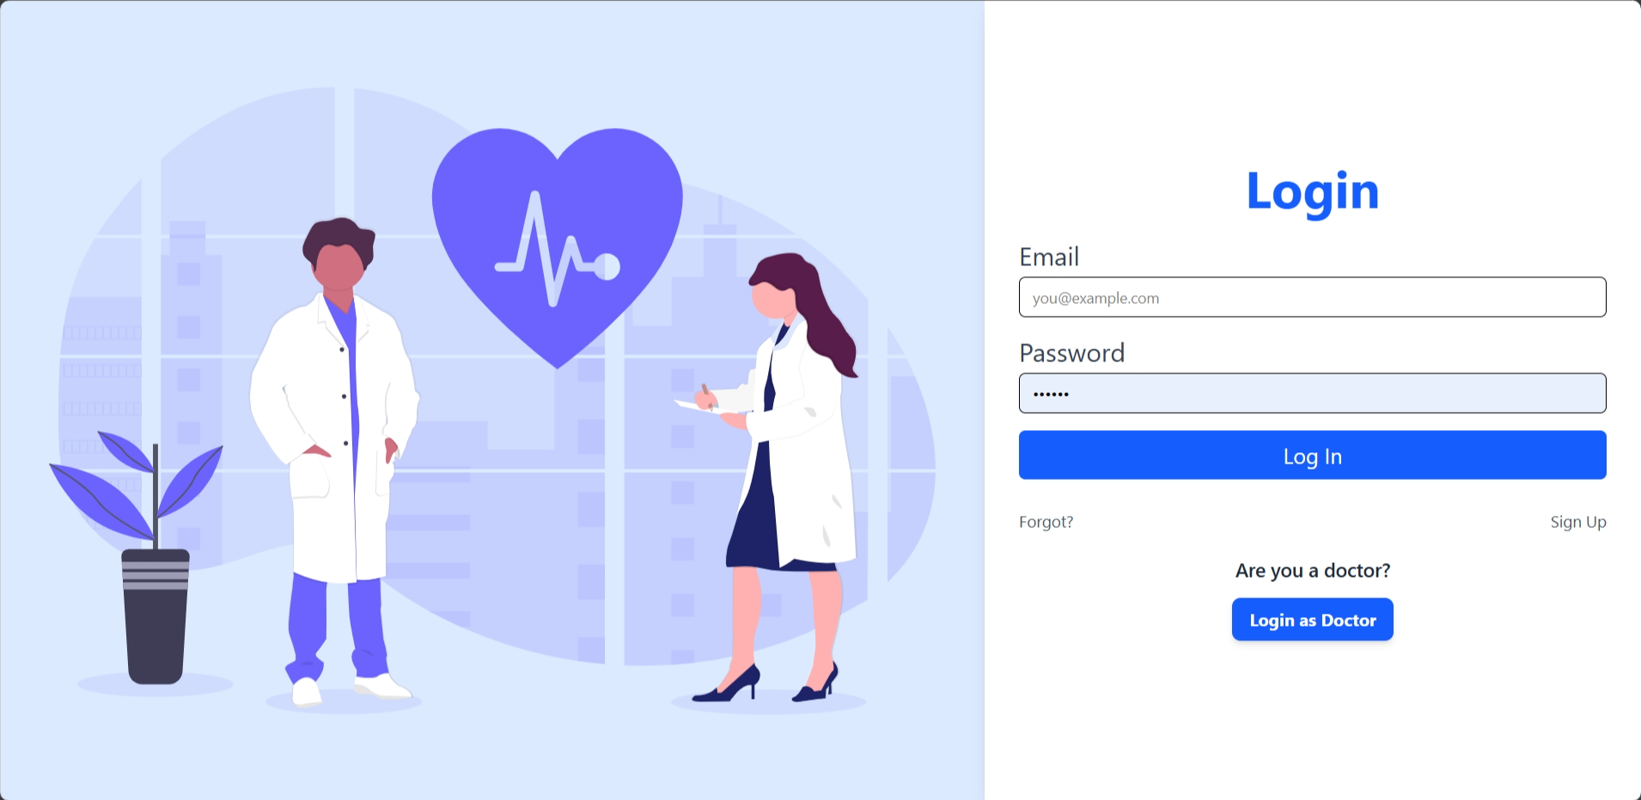

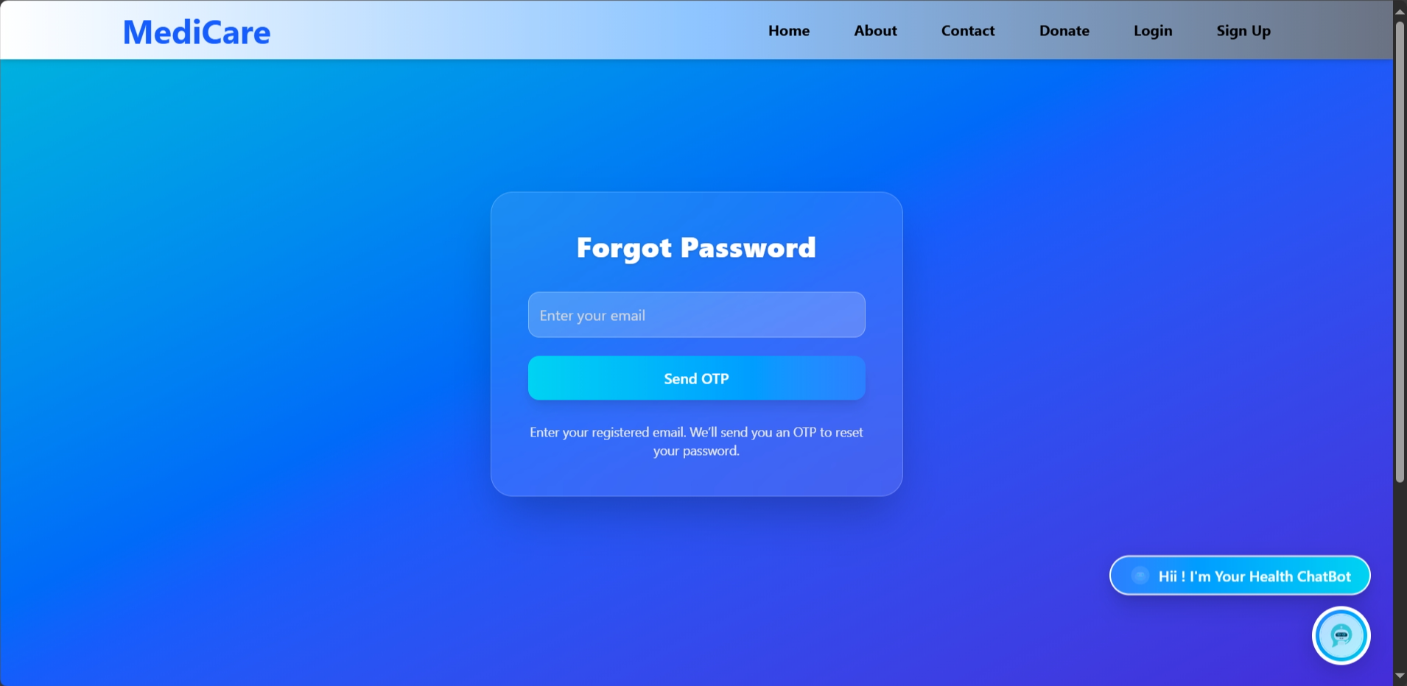

Other weekly tasks

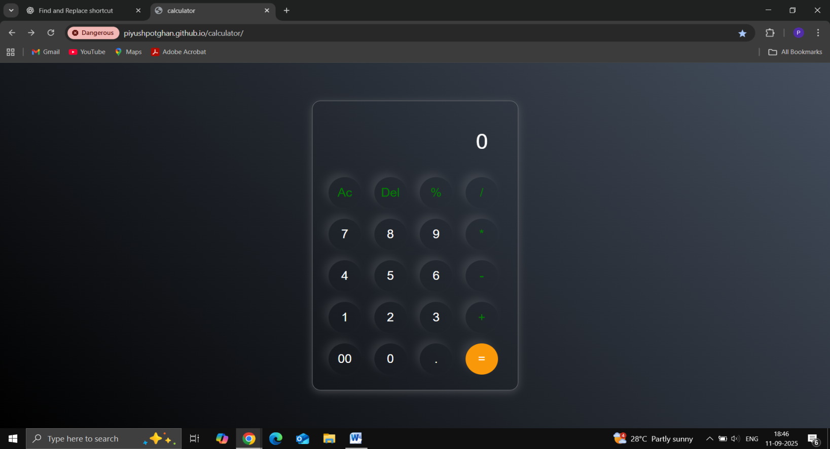

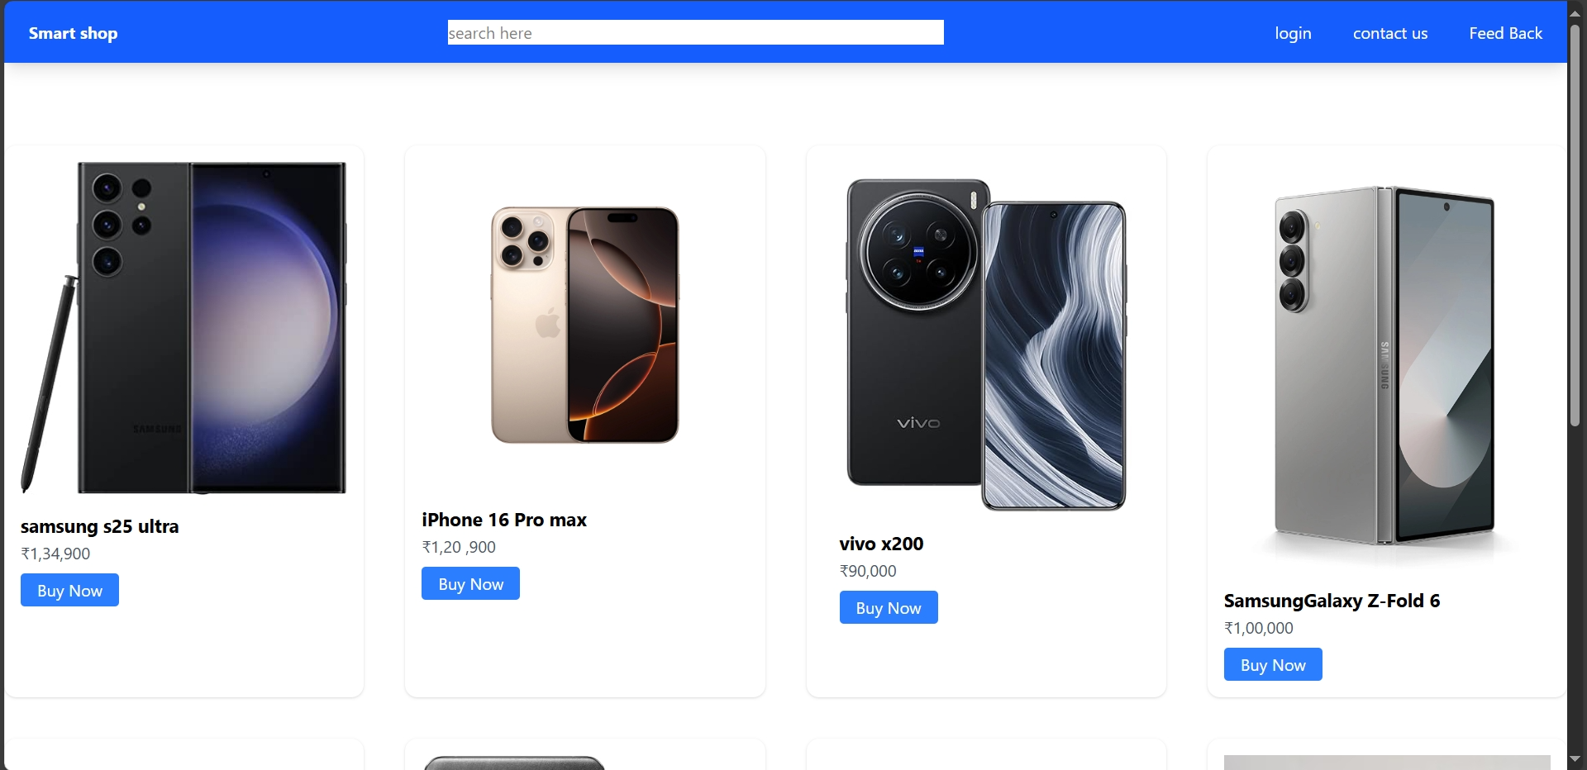

CHAPTER 9:

Special/Challenging Experiences Encountered

Every live project or industrial training work involves not only routine activities but also situations that require extra effort, problem-solving skills, and adaptability. While working on the Medicare – Doctor Appointment System, I also faced several such challenges which tested my technical, organizational, and time-management abilities. Overcoming these difficulties provided me with real-world exposure to how projects are developed and managed in a professional environment.

1. Technical Challenges
• Implementing JWT authentication and role-based authorization for three different users (Admin, Doctor, Patient) was complex.
• Designing a scalable database schema in MongoDB that could handle multiple collections (appointments, prescriptions, doctors, users).
• Debugging integration issues while connecting the React frontend with Node.js APIs.
• Handling errors in asynchronous API calls and optimizing queries for faster data fetching.

2. Organizational Challenges
• Coordinating different modules like Appointments, Prescriptions, Doctors, and Patient Records to ensure smooth workflow.
• Maintaining proper documentation of APIs, database schemas, and frontend component structure.
• Structuring the project in a way that made it easy to scale and maintain.

3. Time-Related Challenges
• Completing multiple modules (authentication, appointment booking, admin dashboard) within strict deadlines.
• Balancing frontend design and backend logic simultaneously without compromising quality.
• Ensuring end-to-end testing within limited time before final deployment.

4. Resource Constraints
• Initially working with limited resources such as sample data for testing appointments and prescriptions.
• Developing and testing on a local environment before deploying to a proper server.
• Adapting UI responsiveness with minimal design frameworks.

5. Communication Challenges
• Understanding and implementing project requirements clearly in technical terms.
• Ensuring that features such as appointment flow, prescription upload, and doctor availability matched real healthcare needs.
• Learning to explain technical aspects in simple language when discussing the system with non-technical peers.

6. Illustrative Examples of Special Experiences
• Real-Time Debugging: Solving an issue where appointment records were not being updated correctly due to schema mismatch.
• Applying Classroom Knowledge: Using concepts of database normalization, REST APIs, and React state management in real implementation.
• Decision-Making Under Pressure: Choosing between implementing authentication using sessions vs JWT, and finalizing JWT for better scalability.
• Adapting to Standards: Following proper coding practices, modular design, and Git version control to manage the project effectively.

7. Learnings Gained from Challenging Experiences
- Skill Enhancement: Improved MERN stack knowledge by solving real integration and deployment issues.
- Confidence Building: Gained confidence in handling backend errors and frontend API failures.
- Teamwork and Leadership: Learned how different modules of a system need to be coordinated like a team.
- Time & Resource Management: Learned to prioritize important modules first (authentication, appointments) before adding extra features.
- Professionalism: Developed an understanding of system design principles, coding ethics, and structured documentation.

8. Overall Importance
The special and challenging experiences during this project were highly valuable because they:
• Transformed me from a learner into a practical problem solver.
• Prepared me to face real-world software development challenges.
• Gave me the ability to convert technical problems into learning opportunities.
• Built a strong foundation for my career in web development and IT industry.

CHAPTER 10:
Conclusion
The Medicare – Doctor Appointment System project provided me with practical exposure to MERN stack development and real-time problem-solving. Through this training, I learned how to apply classroom concepts in building a fully functional web application with features like user authentication, role-based dashboards, appointment management, prescription handling, and database management.
The project not only improved my technical knowledge but also enhanced my time management, problem-solving, and professional skills. Overall, this experience has prepared me to face real-world challenges and given me a strong foundation for a career in the IT and healthcare software development sector.

CHAPTER 11:

References / Sources of Information

  - Reference Websites:
  - https://www.npmjs.com/ – NPM (Node Package Manager) library registry
  - https://www.w3schools.com/ – Easy tutorials for HTML, CSS, JS, Node, React
  - https://stackoverflow.com/ – Community Q&A for coding doubts
  - https://www.freecodecamp.org/ – Full tutorials and guides for web dev & MERN
  - https://github.com/ – Open-source code examples & MERN stack projects
  - https://www.geeksforgeeks.org/ – Detailed programming + web dev articles
  - https://www.tutorialspoint.com/ – Reference + practical coding examples
  - https://www.postman.com/ – API testing tool docs & tutorials
  - https://vercel.com/docs – Hosting + deployment docs for React/Node apps
  - https://render.com/docs – Cloud deployment & backend hosting guides

